Design and Development of Project FALCON A Solar-Powered Smart Buoy for Pressure-Based Wave Monitoring and Short-Term Prediction

A Thesis Proposal

Presented to

The Faculty of the Electronics and Computer Technology Department

Fullbright College

In Partial Fulfillment of the

Requirements for the Degree

Bachelor of Science in Information Technology

By

John Ruzzel Correa

Mayla R. Bacaltos

Gina P. Caballero

Saira Caballero

Gwyn Isabel C. Enriquez

October 2026
APPROVAL SHEET
This thesis proposal entitled DESIGN AND DEVELOPMENT OF PROJECT FALCON: A SOLAR-POWERED SMART BUOY FOR PRESSURE-BASED WAVE MONITORING AND SHORT-TERM PREDICTION prepared and submitted by the researchers in partial fulfillment of the requirements for the degree of , has been examined and is recommended for oral defense.
JUAN D. DELA CRUZ, PhD
Research Instructor
JUAN D. DELA CRUZ, PhD
Adviser
Approved in partial fulfillment of the requirements for the degree Bachelor of Science in Information Technology by the thesis examination committee, with a proposal rating of ____ and final oral rating of _____.
JUAN D. DELA CRUZ, PhD
Member
JUAN D. DELA CRUZ, PhD
Member
JUAN D. DELA CRUZ, PhD
Chairperson
Accepted and approved as partial fulfillment of the requirements for the degree of Bachelor of Science in Information Technology.
JEZREEL B. VICENTE, RCrim, PhD
Dean (or Program Coordinator)

ACKNOWLEDGMENT
The researchers sincerely thank their thesis adviser for the guidance, patience, and critical review given throughout the preparation of this study, and for the many corrections that improved both the design and the writing of this proposal.
They also express their gratitude to the Dean, the Chairperson, and the members of the panel for the questions, observations, and recommendations raised during the defense, which directly shaped the direction of the revised design and the testing plan described in this manuscript.
The researchers thank the research instructor for the methods, the documentation practices, and the evaluation approach taught during the course, and they thank those who agreed to participate in the planned activities and to share their time in support of the completion of this study.
Finally, the researchers thank their families and relatives for the moral support, patience, and encouragement that made it possible to continue this work to its present stage.

The Researchers

TABLE OF CONTENTS
PRELIMINARIES
 | Title Page ……………………………………………………………….. Approval Sheet …………………………………………………………. | 1  2
 | Acknowledgement ……………………………………………………... | 3
 | Table of Contents ………………………………………………………. | 4
CHAPTER 1. INTRODUCTION
 | 1.1 Background of the Study………………………………………….. | 11
 | 1.1.1 International Background………………………………….. | 11
 | 1.1.2 National Background……………………………………….. 1.1.3 Local Background…………………………………………… | 11  11
 | 1.2 Review of Related Literature……………………………………… | 11
 | 1.3 Review of Related Studies………………………………………… 1.4 Theoretical and Conceptual Framework………………………… | 11  11
 | 1.5 Significance of the Study………………………………………….. | 12
1.6 Statement of the Problem…………………………………………. CHAPTER 2. METHODOLOGY |  | 12
 | 2.1 Research Design………………………………………………….. | 13
 | 2.2 Population of the Study……………………………………………. | 13
 | 2.3 Locale of the Study………………………………………………… | 13
 | 2.4 Scope and Limitation of the Study……………………………….. | 13
 | 2.5 Data Gathering Tool..……………………………………………… | 13
 | 2.6 Data Gathering Procedure………………………………………… | 13
 | 2.7 Treatment of the Data……………………………………………… | 14
 | 2.8 Ethical Considerations…………………………………………….. | 14
REFERENCES …………………………………………………………………… |  | 17
APPENDICES
A | Letter to the Dean………………………………………………………. | 19
B | Letter to a Key Officer………………………………………………….. | 20
C | Letter to the Participants .……………………………………………… | 21
D | Research Tool ………………………………………………………….. | 22
E | Certificate of Tool Validation ………………………………………….. | 23

CHAPTER 1

INTRODUCTION

1.1 Background of the Study
Coastal areas play an important role in fishing, transportation, and other marine activities, making reliable information about sea conditions essential. However, continuous coastal monitoring can be challenging due to the cost and maintenance of specialized equipment. With advancements in sensor technology, solar energy, and cloud computing, affordable monitoring systems can be developed to help collect and analyze environmental data.
In response, this study aims to develop Project FALCON, a solar-powered smart buoy designed for pressure-based wave monitoring and short-term wave-height prediction. The system integrates sensors, GPS, wireless communication, and a cloud-based monitoring dashboard. It will be tested and evaluated to determine its measurement accuracy, system reliability, and prediction performance as a potential coastal monitoring research platform in Puerto Princesa City, Palawan.

1.1.1 International Context
Ocean monitoring is important for wave forecasting, coastal hazard assessment, marine environmental monitoring, and climate research. Reliable ocean data help researchers understand sea conditions and develop forecasting methods. However, the Global Ocean Observing System (GOOS) reported in 2025 that global ocean observations still had gaps and did not fully meet all monitoring requirements. These challenges show the need for accessible and sustainable ocean-monitoring technologies (Intergovernmental Oceanographic Commission of UNESCO [IOC-UNESCO], 2025).

In 2022, McLeod and Ringwood reviewed different ways to supply power to data buoys in their study, Powering Data Buoys Using Wave Energy: A Review of Possibilities. They explained that batteries and solar panels are commonly used to power data buoys, while wave energy is another possible option that still faces technical challenges. Their study is relevant to Project FALCON because it supports the use of solar power and highlights the importance of choosing a suitable power source for the buoy's needs (McLeod & Ringwood, 2022).
In 2024, Kar et al. developed XWaveNet, a deep-learning model for predicting ocean wave heights and identifying extreme wave events. The model used historical buoy and weather-related data to forecast wave heights for up to 72 hours. The researchers also examined how certain or uncertain the predictions were. Their study shows how machine learning can help predict wave conditions. For Project FALCON, it provides a reference for developing short-term wave prediction, although the method must be tested using the project's own data (Kar et al., 2024).
In 2025, Peláez-Zapata, Pakrashi, and Dias reviewed different technologies used to measure ocean waves in their study, Ocean Wave Measurements for Marine Renewable Energy Applications. They discussed instruments such as wave buoys, acoustic Doppler current profilers, and hydrophones, including their advantages and limitations. Their study highlights the importance of choosing suitable sensors and collecting reliable measurements in marine environments. This is relevant to Project FALCON because pressure readings must be properly processed to estimate wave conditions (Peláez-Zapata et al., 2025).
Synthesis of Studies
The reviewed studies provide three important ideas for Project FALCON: a reliable power supply, accurate wave measurements, and short-term wave prediction. McLeod and Ringwood (2022) discussed power sources for data buoys, Kar et al. (2024) explored the use of deep learning for wave prediction, and Peláez-Zapata et al. (2025) reviewed different wave-measurement technologies.
Together, these studies show that a reliable ocean-monitoring system needs a suitable power source, dependable sensor readings, and a tested prediction method. However, the studies focus on different parts of ocean monitoring rather than testing the exact system proposed for Project FALCON.
Research Gap
Previous studies have explored buoy power systems, wave-measurement technologies, and wave-prediction methods. However, combining these functions into one practical prototype still requires careful development and testing. Project FALCON aims to combine solar power, pressure-based wave monitoring, data collection and transmission, and short-term wave prediction in one system.
The project will evaluate the reliability of wave measurements, solar power performance, data transmission, and prediction accuracy under defined testing conditions. These tests will help determine whether the prototype can perform its intended functions.
Therefore, Design and Development of Project FALCON: A Solar-Powered Smart Buoy for Pressure-Based Wave Monitoring and Short-Term Prediction aims to combine existing technologies into a compact and easy-to-maintain monitoring system. Its main contribution is building and testing the prototype rather than creating entirely new sensing or prediction technologies. The research gap explains the specific need that the project aims to address, but it does not mean that similar systems do not already exist.

1.1.2 National Context
The Philippines is an archipelagic country surrounded by seas, making ocean monitoring important for coastal communities, fishing, transportation, and other maritime activities. Changes in wave conditions can affect coastal operations and create risks for people working or traveling at sea. Reliable wave data can help improve the understanding of sea conditions and support marine weather assessment. Several local studies have examined wave behavior and the use of technology to measure or estimate wave conditions. These studies provide a foundation for developing monitoring systems suited to Philippine coastal environments.
Cabrera, Villanoy, and Siringan (2016), in Wave Climate of the Philippines from Wavewatch III Global Model, analyzed wave conditions around the country using numerical models and available wave observations. Their study examined changes in wave height, period, and direction, highlighting the importance of reliable wave data for understanding the country’s wave climate.
Similarly, Pacaldo, Bilgera, and Abundo (2022) studied nearshore wave energy resources in Cuyo Island, Palawan. They used historical wave data, local wind measurements, and the SWAN wave model to estimate wave conditions during different monsoon seasons. Their findings demonstrated the importance of assessing wave conditions in specific Philippine coastal areas and validating model results against available observations.
In addition, the Department of Science and Technology–Advanced Science and Technology Institute (DOST-ASTI) developed a locally designed meteorological buoy that collects data such as wave height, wave period, wind speed, and temperature. Its improved system also supports real-time data viewing, demonstrating how buoy technology can support environmental monitoring in the Philippines (DOST-ASTI, 2024).
These studies and initiatives show that wave monitoring and data-based analysis are already being explored in the country. However, Project FALCON focuses on developing and evaluating a specific prototype that combines solar-powered operation, pressure-based wave monitoring, data recording, and short-term wave prediction. The prototype will be tested under selected conditions within Puerto Princesa City, Palawan, to assess its measurement performance, power operation, and prediction results. The study aims to contribute a practical prototype using existing technologies while documenting its actual capabilities and limitations.

1.1.3 Local Context
Puerto Princesa City, Palawan, is a coastal area where monitoring wave conditions can support marine research and the collection of environmental data. Changes in wave conditions can affect coastal activities, making reliable measurements useful for understanding how the sea behaves over time. Developing a monitoring system requires suitable sensors, a reliable power supply, proper data processing, and methods for analyzing recorded measurements. These requirements provide the basis for Project FALCON, which focuses on developing a solar-powered smart buoy for pressure-based wave monitoring and short-term prediction.
A recent local study by Madarcos et al. (2026), titled Perceived Climate Change Impacts on Food Security in Coastal Communities of Puerto Princesa City, Philippines, examined residents' observations of environmental changes in coastal communities. The study reported that 69% of participants perceived changes in wave intensity compared with ten years earlier. Although this finding does not provide direct measurements of wave height or pressure, it highlights local interest in understanding changes in coastal conditions. It also shows the importance of distinguishing personal observations from measurements collected through monitoring instruments. Project FALCON addresses the technical side of this need by proposing a system that collects measurable pressure data for further analysis. However, the proposed prototype will need actual testing before its ability to represent wave conditions can be established (Madarcos et al., 2026).

A relevant Philippine technology initiative is the Meteorological Buoy developed by the Department of Science and Technology–Advanced Science and Technology Institute (DOST-ASTI). The original buoy was deployed in Aborlan, Palawan, in September 2014 and was designed to collect environmental measurements, including wave height, wave period, wind speed, wind direction, air pressure, and sea-surface temperature. DOST-ASTI continued improving the system through its Metbuoy+ project. According to its 2024 Annual Report, the project incorporated an intelligent solar-charged controller, improved power monitoring and recovery, and additional water-quality sensors. These improvements aim to support reliable environmental monitoring and reduce data loss during system interruptions (DOST-ASTI, 2024).
The DOST-ASTI initiative is relevant to Project FALCON because it demonstrates how sensors, electronic controllers, solar-based power management, and data-handling functions can be combined in a buoy system. However, the two projects have different scopes. The DOST-ASTI buoy is designed for broader meteorological and environmental monitoring, while Project FALCON will focus on pressure-based wave measurements and the development of a short-term prediction function. The existing initiative therefore provides a local technical reference, but it does not establish the performance of the particular hardware combination proposed for Project FALCON.
For its monitoring component, Project FALCON proposes a submersible pressure transmitter to collect water-pressure measurements associated with wave activity. The analog signal will pass through an appropriate signal-conditioning and protection circuit before being converted into digital readings by an ADS1115 analog-to-digital converter. An ESP32 microcontroller will process the readings and support the transfer of collected data to the software component for recording and analysis. This proposed arrangement will require suitable electrical interfacing, calibration, and testing to ensure that the sensor output can be interpreted correctly. In particular, pressure readings cannot automatically be treated as wave height; the relationship must be established through appropriate measurement methods and signal processing.
The proposed power system will use solar panels and a rechargeable battery to supply electricity to the buoy's electronic components. This arrangement is intended to support operation without relying entirely on a continuous external power supply. However, the actual operating duration will depend on the energy produced by the solar panels, battery capacity, weather conditions, and the power consumed by the system. Therefore, the prototype's power performance must be measured during testing rather than assumed from the components' rated specifications alone. This evaluation is relevant to the development of a buoy intended to collect data over a period of time.
The software component will record the collected measurements and organize them for analysis. These records will serve as input for developing and evaluating the short-term prediction function. The prediction method and forecast period will need to match the amount, quality, and sampling frequency of the available data. Its performance should be assessed by comparing predicted values with actual measurements that were not used to generate those predictions. This process will help determine whether the prototype can produce useful short-term estimates under the selected testing conditions.
Synthesis of Local Studies
The reviewed local sources provide two useful forms of evidence for Project FALCON. Madarcos et al. (2026) documented residents' perceptions of changing wave intensity in Puerto Princesa City, highlighting the local relevance of understanding coastal conditions. Meanwhile, the DOST-ASTI Meteorological Buoy and its continuing development demonstrate the use of sensors, electronic control, solar-based power management, and data collection for marine and environmental monitoring in the Philippines. Together, these sources support the importance of observing coastal conditions and developing reliable systems for collecting environmental data.
However, the two sources have different purposes and limitations. Madarcos et al. (2026) examined community perceptions rather than direct instrument-based wave measurements. The DOST-ASTI buoy collects a broader range of environmental parameters, but its documented objectives do not establish the performance of Project FALCON's proposed pressure-sensor arrangement and short-term prediction function. Neither source should therefore be treated as proof that the proposed prototype will already achieve a particular level of measurement or prediction accuracy.
Research Gap
Based on these sources, the research gap for Project FALCON concerns the development and evaluation of a specific combination of existing technologies. The study proposes to integrate a pressure transmitter, ADS1115 analog-to-digital converter, ESP32 microcontroller, solar panels, rechargeable battery, and software for data recording and short-term wave prediction. The reviewed sources do not establish how this exact configuration will perform under the proposed testing conditions in Puerto Princesa City. This is a specific development gap, not a claim that wave-monitoring buoys are absent from the Philippines.
To address this gap, the researchers will develop the prototype and evaluate its ability to collect and record pressure measurements, operate using the proposed solar-powered system, and generate short-term predictions from the collected data. Testing will examine measurement performance, power operation, data-recording reliability, and prediction results. Calibration and appropriate signal processing will be necessary to relate pressure measurements to wave behavior, while the prediction function will be assessed against suitable reference measurements where available.

The specific testing location within Puerto Princesa City has not yet been selected. It will be determined based on the suitability of the site for pressure-based measurements, accessibility, safety, and the necessary permissions. The findings will be limited to the data collected and the conditions under which the prototype is tested. Through this process, Project FALCON aims to provide an evaluated prototype that combines solar-powered operation, pressure-based wave monitoring, and short-term prediction, while documenting its actual performance, limitations, and possible improvements.

1.2 Review of Related Literature
This section presents and discusses relevant studies, theories, and existing technologies related to the development of Project FALCON. It focuses on key concepts and principles in solar-powered smart buoys, pressure-based wave monitoring, IoT-based environmental monitoring, and short-term wave-height prediction to establish the foundation of the study.
1.2.1 Foreign and Local Literature
IoT-based aquatic environmental sensing. Trevathan and Schmidtke (2022) describe an open-source Internet of Things platform for remote aquatic environmental sensing. Their work shows how low-cost microcontrollers, sensors, local logging, and remote access can be combined for field observation. Project FALCON adopts this principle through an ESP32 acquisition node, local buffering, and a cloud dashboard, while adding a pressure-based wave-monitoring objective.
Pressure measurement and wave-height estimation. Lyman et al. (2020) explain that a submerged pressure sensor can capture pressure variations associated with surface waves when the sensor is calibrated, protected from direct impact, and interpreted with the sensor depth and water density considered. This literature supports the proposed stilling-tube arrangement and the decision to label the output as an estimated wave height until it is validated against an independent reference.
Marine sensor data quality. Skålvik et al. (2023) identify drift, biofouling, deployment conditions, and sensor-specific uncertainty as important sources of error in marine measurements. These findings justify the inclusion of range checks, quality flags, calibration records, leak inspection, and separate verification data in Project FALCON.
Coastal and Philippine monitoring context. Cabrera, Villanoy, and Siringan (2016) describe the value of wave-climate information for the Philippines, while Pacaldo, Bilgera, and Abundo (2022) demonstrate the importance of nearshore wave assessment in an island setting. Together, these sources support the need for locally collected coastal observations that can complement larger regional models.
Environmental monitoring and prediction. Yevnin et al. (2023) and Zhao et al. (2024) discuss short-term wave forecasting and machine-learning applications in physical oceanography. Their work supports a cautious prediction component for Project FALCON: the system may produce a short-horizon estimate only after sufficient valid history is available, and the estimate must be compared with a reference and a transparent baseline.
Solar-powered and autonomous buoy design. Zhang, Zhang, and Zhang (2020) and Williams et al. (2025) show that multifunctional buoys require coordinated sensing, power management, communication, mechanical protection, and remote data handling. These studies reinforce the proposed compact body, sealed enclosure, solar charging, battery monitoring, GPS, wind sensing, and cloud-linked architecture.
Synthesis of the literature. The literature indicates that a useful low-cost buoy must combine reliable sensing, documented calibration, power-aware operation, communications recovery, and a clear distinction between measured values and derived estimates. Project FALCON addresses this combined requirement in a compact design intended for proposal-stage validation in Puerto Princesa City.

1.3 Review of Related Studies
This section reviews existing studies and systems related to the development of Project FALCON. It aims to examine current technologies in solar-powered smart buoys, pressure-based wave monitoring, environmental data collection, and short-term wave-height prediction, while identifying research gaps that the present study seeks to address.
1.3.1 Local Studies
DOST–ASTI (2024) reported the continuing development of a meteorological buoy for fish-kill forecasting. The report demonstrates the Philippine value of continuous marine observation and shows that environmental data can support operational decisions. Project FALCON is narrower and lower-cost, focusing on pressure-derived wave indicators, wind, GPS, and cloud reporting for a proposed nearshore deployment.
Pacaldo, Bilgera, and Abundo (2022) assessed nearshore wave-energy resources in Cuyo Island, Palawan. Their results show why site-specific wave observations matter in Philippine island environments. Project FALCON responds to the same local-data need with a small prototype designed for repeatable short-interval observation.
Cabrera, Villanoy, and Siringan (2016) used a global wave model to describe the wave climate of the Philippines. The study provides regional context but does not provide a low-cost, locally deployable sensor platform for collecting observations at a selected coastal site. This limitation motivates the proposed field-oriented prototype.
1.3.2 Foreign Studies
Lyman et al. (2020) developed the Open Wave Height Logger using pressure sensing and open-source electronics. The study is directly relevant to the pressure channel, but Project FALCON extends the concept with wind, GPS, battery/solar monitoring, event-aware transmission, cloud storage, and a dashboard.
Trevathan and Schmidtke (2022) developed a remote aquatic IoT sensing platform. Its contribution is the integration of low-cost hardware and remote access; Project FALCON applies the same integration to wave-related coastal observations and adds a documented pressure-processing and validation workflow.
Zhang, Zhang, and Zhang (2020) presented a multifunctional buoy for continuous environmental monitoring at Tianjin Port. Their work demonstrates the value of combining multiple sensors and communications, while Project FALCON prioritizes a smaller body, a simpler equipment set, and a lower proposal-stage budget.
Yevnin et al. (2023) evaluated gated recurrent-unit models for short-term wave forecasts. Their work supports the prediction objective, but Project FALCON will first establish a transparent baseline and will not present a prediction as validated until it passes a held-out comparison.
Williams et al. (2025) described a low-cost autonomous multifunctional buoy for ocean-current, seawater-parameter, and particle-tracking applications. The study supports the feasibility of compact autonomous platforms and informs the proposed modular approach, although the present study concentrates on pressure-derived wave indicators and basic meteorological/security data.
1.3.3 Synthesis of Gaps
The reviewed studies establish that pressure sensors, IoT communications, solar power, cloud dashboards, and prediction methods can support marine observation. However, the literature and local reports leave a practical gap for a compact and documented Philippine prototype that combines pressure-based wave estimation, wind and GPS context, low-power packet scheduling, local buffering during Internet loss, and a panel-ready validation rubric. Project FALCON is intended to address that gap. Its contribution is a validated prototype design and evaluation plan rather than a claim of field-ready deployment.

1.4 Theoretical and Conceptual Framework
This section presents the research foundations that guide the development and evaluation of Project FALCON. It discusses the principles of IoT-based environmental monitoring, pressure-based wave measurement, and short-term wave-height prediction. It also presents the conceptual framework illustrating the relationship between the system's inputs, development and testing processes, and expected outputs.

1.4.1 Theoretical Framework
This study is guided by three research-based foundations: IoT-Based Environmental Monitoring, Pressure-Based Wave Measurement, and Short-Term Wave-Height Prediction. These foundations support the development of Project FALCON, a solar-powered smart buoy designed to collect coastal environmental data, estimate wave height, and generate short-term wave predictions.
IoT-Based Environmental Monitoring
Trevathan and Schmidtke (2022), in their study Open-source Internet of Things Remote Aquatic Environmental Sensing, developed an IoT platform for collecting and remotely monitoring aquatic environmental data. Their study demonstrates how sensors, microcontrollers, communication modules, and dashboards can be integrated into a monitoring system.
This foundation is directly applicable to Project FALCON because the proposed system integrates an ESP32 microcontroller, environmental sensors, GPS/GNSS, solar power, wireless communication, and a cloud-based dashboard. These components will work together to collect, transmit, store, and display coastal observations. System testing will determine whether the integrated components function reliably.
Pressure-Based Wave Measurement
Lyman et al. (2020), in their study Open Wave Height Logger: An Open Source Pressure Sensor Data Logger for Wave Measurement, developed a pressure sensor data logger for measuring wave conditions. Their research supports the use of underwater pressure measurements for wave analysis and demonstrates the importance of comparing pressure-derived estimates with reference buoy measurements.
This foundation is relevant to Project FALCON because its underwater pressure sensor will collect data that will be processed to estimate wave height. The researchers will compare these estimates with suitable reference measurements to assess accuracy and consistency. This validation will help identify measurement errors and limitations in the prototype.
Short-Term Wave-Height Prediction
Yevnin et al. (2023), in their study Short-term wave forecasts using gated recurrent unit model, investigated machine-learning techniques for predicting wave height using recent observations and existing forecast data. Their research demonstrates the potential of data-driven models to improve short-term wave forecasting.
This foundation supports Project FALCON's prediction component, which will use available wave-related data to generate short-term wave-height estimates. The prediction results will be compared with reference data and an appropriate baseline method to evaluate prediction errors and performance. The results will establish the prototype's actual predictive capability under the tested conditions.
Application to Project FALCON
These three foundations address the main functions of Project FALCON: IoT-based environmental data collection, pressure-derived wave-height estimation, and short-term wave prediction. Together, they guide the system's development and experimental evaluation. The study will determine the prototype's monitoring reliability, measurement accuracy, and prediction performance based on actual test results.

1.4.2 Legal Basis
The development of Project FALCON is guided by Philippine laws related to environmental monitoring, disaster preparedness, climate change, and data privacy. These laws provide relevant support for developing a solar-powered smart buoy for pressure-based wave monitoring and short-term wave-height prediction.
Republic Act No. 10692 – PAGASA Modernization Act of 2015. This law supports the modernization of weather monitoring and forecasting services. Project FALCON aligns with these objectives by collecting coastal environmental data and generating experimental wave-height predictions. However, it is not intended to replace official forecasts or warnings.
Republic Act No. 10121 – Philippine Disaster Risk Reduction and Management Act of 2010. This law promotes disaster preparedness and risk reduction. Project FALCON may provide supplementary research data on coastal wave conditions that can support future monitoring efforts. However, the system is not an official disaster warning system.
Republic Act No. 9729 – Climate Change Act of 2009. This law promotes the integration of climate change considerations into government policies and programs. Project FALCON supports related research by monitoring coastal environmental conditions and generating data that may contribute to the study of wave behavior.
Republic Act No. 10173 – Data Privacy Act of 2012. This law is relevant when Project FALCON collects or processes personal information during system testing and evaluation. The researchers will observe the principles of transparency, legitimate purpose, and proportionality.
- Transparency: Participants will be informed about the purpose of collecting personal information during Project FALCON's testing and evaluation.
- Legitimate Purpose: Personal information will be processed only for lawful research activities related to system testing, evaluation, and usability assessment.
- Proportionality: Only personal information necessary to evaluate the system will be collected.
Furthermore, appropriate safeguards will be implemented to protect personal information, including user details and dashboard account records, and restrict access to authorized individuals. Environmental measurements collected by Project FALCON, such as pressure readings, wave-height estimates, and wind data, are not automatically considered personal information. Any identifiable information will be handled responsibly in accordance with applicable data protection requirements.

1.4.3 Conceptual Paradigm
The conceptual paradigm follows an Input–Process–Output (IPO) model with validation and feedback. Inputs include water-pressure observations, wind speed and direction, GPS position and security status, battery and solar telemetry, and the user, site, and system requirements. The process includes ESP32 data acquisition and quality checking, calibration and pressure-signal processing, two-minute summarization, local buffering, Internet transmission, cloud storage, wave-height estimation, short-term prediction, and controlled evaluation. Expected outputs include an integrated prototype, traceable environmental records, pressure-based wave-height estimates, dashboard information, short-term predictions, and performance evidence. Evaluation results return to the development process as feedback for calibration, hardware, firmware, cloud-processing, and interface refinement.
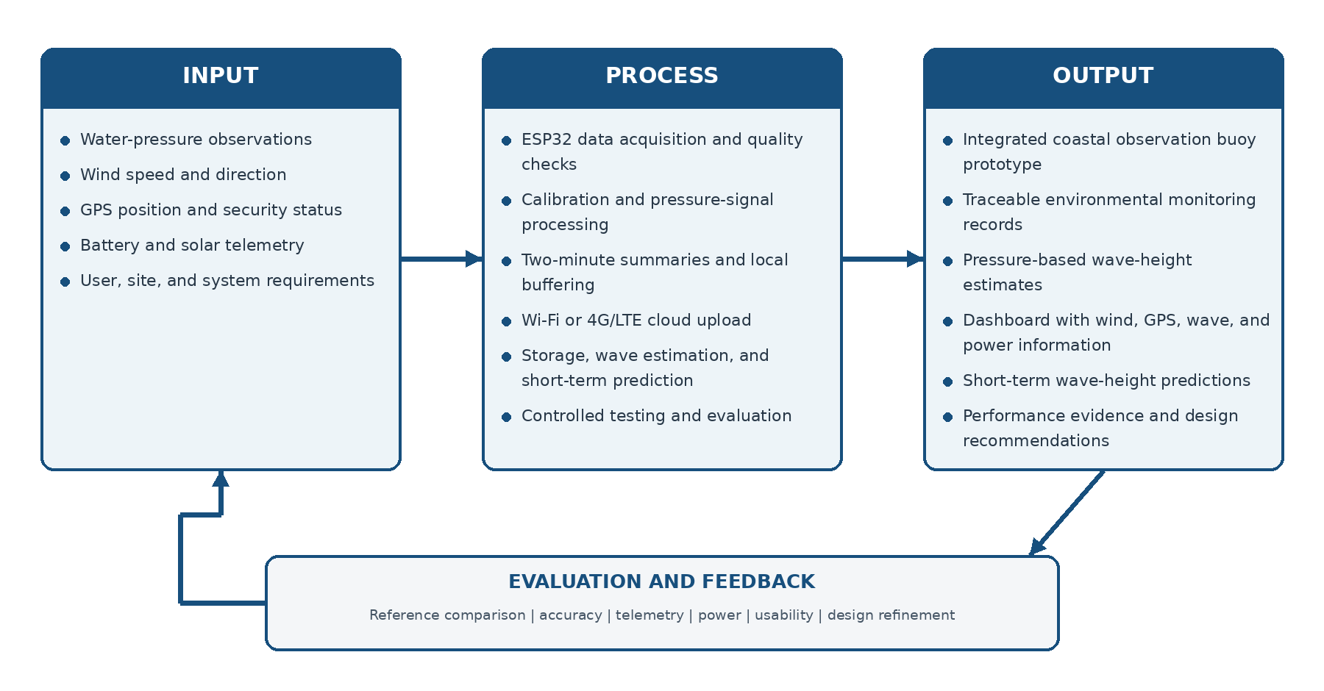
Figure 1.1. Input-Process-Output conceptual paradigm of Project FALCON
A. Input
The Input block represents the essential data, system requirements, and operational resources needed for the development and operation of Project FALCON, a solar-powered smart buoy for pressure-based wave monitoring and short-term wave-height prediction.
- Water Pressure Observations: These refer to the pressure readings collected by the underwater pressure sensor. The data serve as the primary input for estimating wave height and monitoring wave conditions.
- Wind Speed and Direction: These include wind measurements collected by the system to provide additional environmental information that helps describe coastal conditions.
- GPS Position and Security: These refer to the buoy's geographical location and the security requirements needed to support location tracking and protect system access.
- Battery and Solar Telemetry: This includes information about the solar power supply, battery condition, and available energy needed to maintain the buoy's operation.
- User and Site Requirements: These include the functional requirements, monitoring needs, and deployment conditions considered in designing Project FALCON for its intended coastal research application.
B. Process
The Process block represents the procedures performed by Project FALCON to transform collected environmental data into organized monitoring records, estimated wave conditions, and short-term research predictions.
- ESP32 Data Acquisition and Checks: The ESP32 collects readings from connected sensors and performs initial checks to identify missing or invalid data before further processing.
- Calibration and Signal Filtering: The collected readings are calibrated and filtered to reduce measurement errors and unwanted noise, improving data quality.
- Two-Minute Data Summaries: The system organizes collected measurements into two-minute data summaries to support consistent monitoring and subsequent analysis.
- Wi-Fi or LTE Cloud Upload: The processed data are transmitted through an available Wi-Fi or LTE connection to the cloud platform for storage, visualization, and remote access.
- Storage, Analysis, and Prediction: The collected data are stored and analyzed to estimate wave conditions and generate short-term wave-height predictions using the study's prediction component.
- Controlled Validation: The system's measurements and predictions are evaluated against reference measurements or other appropriate validation data to assess accuracy and performance under tested conditions.
C. Output
The Output block represents the information and evaluation results generated by Project FALCON after processing and analyzing the collected environmental data.
- Traceable Monitoring Records: These are the stored environmental measurements and system records that allow researchers to review and track the collected data.
- Estimated Wave Conditions: These include estimated wave-height values derived from pressure measurements and processed sensor data.
- Wind and Position Information: These provide recorded wind speed, wind direction, and GPS location to give additional context to the monitored coastal conditions.
- Dashboard and Security Alerts: These refer to the information displayed on the cloud-based dashboard and alerts related to monitoring or security, depending on the implemented functions.
- Short-Term Research Prediction: This output consists of short-term wave-height predictions generated from collected data for research and experimental evaluation.
- Performance Evidence: These are the testing and validation results, including measurement accuracy, prediction performance, and system reliability, used to determine whether Project FALCON meets its intended objectives.
D. Validation and Feedback
The Validation and Feedback component represents the continuous evaluation of Project FALCON to identify areas for improvement and ensure that the system performs according to its intended requirements.
- Reference Comparison: The system's estimated wave heights are compared with suitable reference measurements to evaluate measurement accuracy and prediction performance.
- Power Evaluation: The solar panel and battery are assessed to determine whether the power system can support the buoy's operation during testing.
- Telemetry Evaluation: The transmission and recording of sensor data are checked to determine whether information is collected and delivered consistently.
- Usability Evaluation: The dashboard and monitoring functions are assessed to determine whether users can access and understand the presented environmental information.
- Design Refinement: Findings from testing and evaluation are used to identify necessary improvements to the buoy's hardware, data-processing procedures, cloud platform, and overall system design.
The results of the validation and feedback process may be used to refine Project FALCON and support further development and testing until the system meets its defined research objectives.

1.5 Significance of the Study
Coastal residents and fisherfolk
The study may provide a readable source of local research observations about pressure-derived wave activity, wind, and data freshness. The output is decision support for evaluation and education and does not replace official forecasts or personal safety judgment.
Barangay and local government offices
The project can demonstrate the requirements, costs, limitations, and maintenance needs of a locally managed near-shore monitoring platform. Its findings may guide decisions about whether further investment or partnership with technical agencies is justified.
Disaster risk reduction and coastal-management personnel
The evaluation can provide evidence about communication outages, power autonomy, GPS drift, and data-quality flags that are relevant when assessing small monitoring technologies. Only validated information should be considered for planning, and the prototype must not be used as an official warning instrument.
Fullbright College and its students
The project integrates embedded systems, networking, databases, cloud services, web development, cybersecurity, renewable energy, testing, and machine learning in one traceable capstone. The resulting documentation and dataset can support instruction and future applied research.
Researchers and future developers
The study will document component choices, calibration procedures, source labels, firmware and schema versions, test results, limitations, and failed assumptions. This allows later teams to reproduce, challenge, or improve the design instead of treating the prototype as a black box.
Government and scientific partners
DOST, PAGASA, NAMRIA, and partner institutions may use the findings as student-scale evidence about the opportunities and limitations of affordable coastal IoT platforms. The work is complementary and does not claim equivalence with agency instruments.

1.6 Statement of the Problem
Coastal monitoring presents challenges in collecting reliable environmental data and estimating wave height, particularly when monitoring equipment requires a stable power supply, dependable data transmission, and accurate sensor measurements. Without an integrated monitoring platform, collecting, storing, and accessing coastal data for analysis can become difficult. Furthermore, pressure-based wave-height estimation and short-term wave-height prediction need to be evaluated to determine their accuracy and reliability under the intended testing conditions.
In light of these challenges, the goal of this study is to:
- To design and develop Project FALCON, a solar-powered smart coastal observation buoy that integrates an ESP32 microcontroller, environmental sensors, GPS, wireless communication, and a cloud-based dashboard for coastal data collection and monitoring.
- To evaluate the performance of Project FALCON in terms of sensor data acquisition, pressure-based wave-height estimation accuracy, data transmission and storage, and solar-battery power performance under the tested conditions.
- To develop and evaluate a short-term wave-height prediction component using collected environmental data and compare its performance with a selected baseline prediction method.
- To assess the functionality, information quality, and usability of Project FALCON's cloud-based dashboard for presenting and accessing coastal monitoring data.

CHAPTER 2

METHODOLOGY

2.1 Research Design
This study will use Design and Development Research to develop, test, and evaluate Project FALCON, a solar-powered smart coastal observation buoy and cloud monitoring platform for pressure-derived wave monitoring and AI-assisted short-term wave-height prediction. This approach is appropriate because the study involves designing and developing a
The study will use a primarily quantitative approach, supported by qualitative feedback. Experimental evaluation will assess wave-height measurement accuracy, communication reliability, data completeness, power consumption, battery performance, GPS behavior, usability, and AI-assisted prediction accuracy. Qualitative feedback will help identify problems and areas for improvement.
The development process will include requirements analysis, system design, system development and integration, testing, evaluation, and revision. The system will transmit summarized sensor data every two minutes while storing raw pressure data for validation. Measurements and predictions will be compared with suitable reference instruments and baseline forecasting methods to evaluate performance and guide further improvements.

2.1.1 Design and Development Research
Design and Development Research involves creating and evaluating a solution to address a specific problem. Benfell (2021) discussed how a design science research methodology can guide the development and testing of a solution in a real-world situation. In this study, this approach will guide the development of Project FALCON, including its sensors, hardware, solar power supply, communication system, cloud platform, and AI prediction component. Testing results will be used to identify problems, improve the prototype, and determine whether it meets the project objectives.

2.1.2 Experimental Evaluation
Experimental evaluation will assess Project FALCON under defined testing conditions through bench testing, controlled water testing, and limited near-shore validation, when feasible. The evaluation will measure wave-height accuracy, sensor agreement and repeatability, data completeness, packet delivery, transmission latency, recovery after communication loss, power consumption, battery performance, system autonomy, GPS behavior, and AI-assisted short-term wave-height prediction accuracy. Predictions and measurements will be compared with suitable reference instruments and baseline forecasting methods. The collected data will be analyzed using appropriate performance metrics to determine whether the system meets its requirements and identify areas for improvement.

2.1.3 Iterative Development Methodology
The Iterative Development Methodology will improve Project FALCON through repeated cycles of testing, evaluation, and revision. Each cycle involves identifying problems, implementing changes, and retesting the system, allowing test results to guide improvements (Tahera et al., 2019).
Modifications may involve hardware, sensor calibration, solar power, communication, software, the cloud platform, data processing, or AI prediction. Further testing will determine whether these changes improve performance and help the prototype meet its established requirements.
Iterative Project Development Process

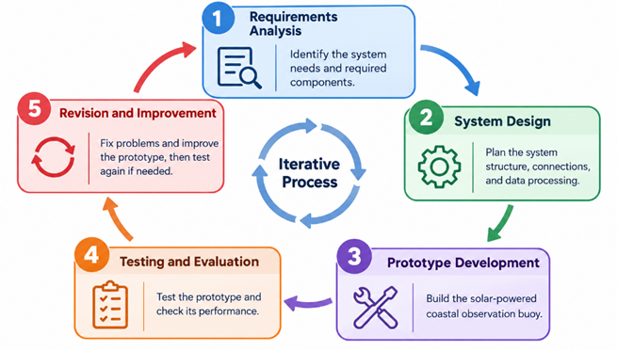
Figure 2.1. Iterative Project Development Process
The development of Project FALCON will follow five main stages:
- Requirements Analysis
This stage identifies the project objectives, system requirements, evaluation criteria, and necessary hardware and software for wave monitoring, solar power, data transmission, cloud monitoring, and AI-assisted short-term wave-height prediction.
- System Design
This stage plans the system architecture, hardware connections, pressure sensor, solar power supply, communication system, cloud platform, data processing, sampling requirements, data storage, and AI prediction component.
- System Development and Integration
This stage involves building the solar-powered buoy and integrating its hardware and software, including the pressure sensor, solar power system, communication module, cloud platform, and AI prediction component.
- Testing and Evaluation
This stage evaluates the system through bench testing, controlled water testing, and limited near-shore validation. Performance is assessed based on wave-height accuracy, data completeness, communication reliability, transmission latency, power consumption, battery performance, and prediction accuracy using suitable reference instruments and baseline forecasting methods.
- Revision and Improvement
This stage involves analyzing test results, identifying problems, and modifying the hardware, software, sensor calibration, power management, communication system, cloud platform, or AI prediction component. The system is retested, and the development cycle is repeated as needed to improve performance and meet the established requirements.

2.2 System Architecture / Framework
Project FALCON is designed with an integrated system architecture that connects the buoy's environmental sensors, ESP32 microcontroller, wireless communication system, cloud platform, and web-based monitoring dashboard. The architecture illustrates how environmental data are collected, processed, transmitted, stored, and presented for pressure-based wave-height estimation and short-term wave-height prediction.
The system consists of four main functional layers: the Data Acquisition Layer, Communication Layer, Cloud Application and Data Layer, and Presentation Layer. A solar-powered supply supports the operation of the buoy's electronic components, while the connected hardware and cloud platform enable remote access to the collected environmental information.
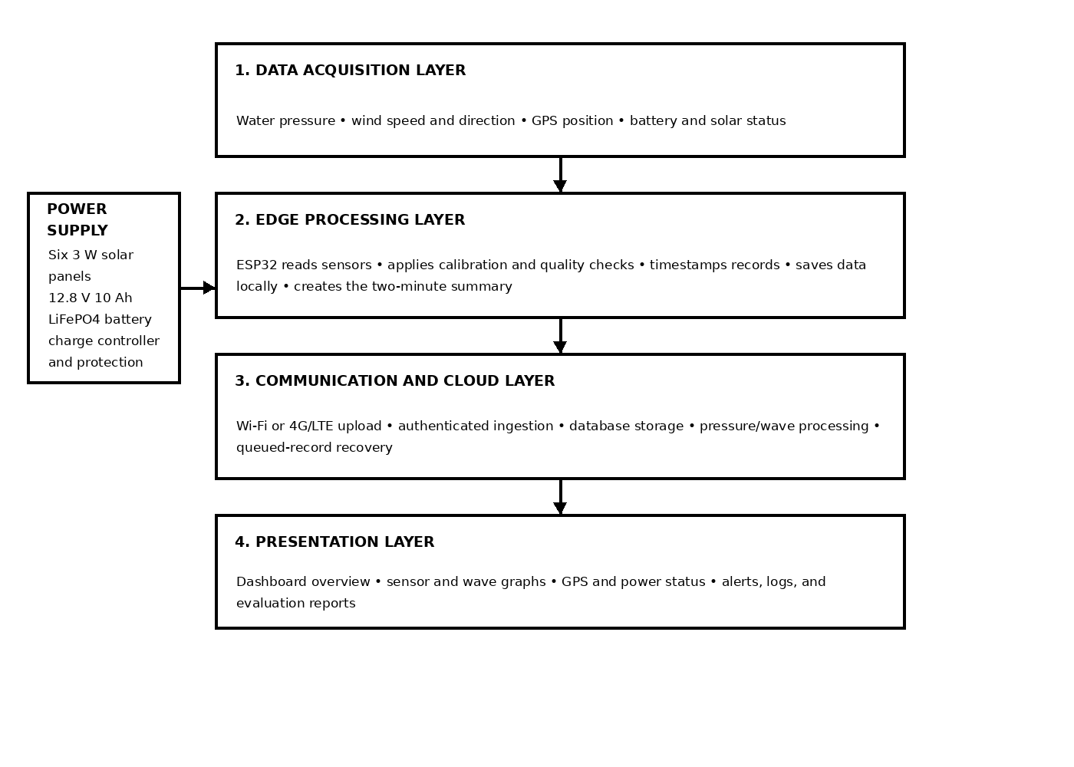
Figure 2.2. System Architecture of Project FALCON

2.2.1 System Architecture (Logical Separation)
The system architecture separates Project FALCON into four functional layers. Each layer performs a specific task while communicating with the other components to support environmental data collection, processing, and monitoring.
- Data Acquisition Layer
The Data Acquisition Layer consists of the physical sensors and ESP32 microcontroller installed in the buoy. The underwater pressure sensor collects water-pressure measurements used for wave-height estimation. The wind sensors collect wind speed and direction, while the GPS module provides the geographical location of the buoy.
The ESP32 serves as the main controller responsible for collecting sensor readings, performing initial data checks, and preparing the information for transmission. A solar panel and battery supply electrical power to the buoy's electronic components. The performance of the power supply will be evaluated during system testing.
- Communication Layer
The Communication Layer enables the transfer of environmental data from the buoy to the cloud platform. Depending on the actual configuration, the system uses the available wireless communication method, such as Wi-Fi or LTE, to transmit collected sensor readings.
This layer supports the transmission of pressure measurements, wind observations, GPS information, and other available system data. Its performance will be evaluated in terms of data delivery and transmission reliability, including recovery from communication interruptions if the corresponding functionality is implemented.
- Cloud Application and Data Layer
The Cloud Application and Data Layer receives, stores, and processes the environmental data transmitted by the buoy. It manages the collected information and makes it available for monitoring, analysis, and visualization.

Within this layer, pressure measurements are processed using the selected method to estimate wave height. The short-term wave-height prediction component analyzes available data to generate predictions for evaluation. These predictions will be compared with appropriate reference measurements and a selected baseline method, provided these are included in the study's implementation and testing procedures.
Presentation Layer
The Presentation Layer serves as the user interface of Project FALCON. It consists of a web-based monitoring dashboard that presents available environmental readings, estimated wave heights, GPS location, and short-term prediction results.
Through the dashboard, researchers and authorized users can remotely access and review the information collected by the buoy. The dashboard will be evaluated in terms of functionality, information quality, and usability to determine whether it presents the monitoring data clearly and effectively.

2.2.2 Cloud Architecture (Deployment Environment)
Project FALCON uses a cloud-based deployment approach to support the storage, processing, and remote visualization of environmental data collected by the buoy. The cloud platform connects the physical monitoring device to the dashboard, allowing researchers to access and analyze collected information remotely.
During operation, the ESP32 collects sensor readings and prepares them for transmission through the available wireless network. The cloud platform receives the transmitted data and makes them available for storage, pressure-based wave-height estimation, short-term prediction, and dashboard visualization.
The specific deployment model depends on the cloud platform and database selected for the project. If managed application hosting or a managed database is used, the corresponding cloud service models may be identified based on the actual services implemented. These details will be specified according to the technologies selected by the researchers.
Overall, this architecture integrates environmental sensing, wireless data transmission, cloud-based data management, wave-height estimation, short-term prediction, and remote monitoring into a single coastal observation system. Its performance will be evaluated in terms of measurement accuracy, communication reliability, power performance, prediction capability, and dashboard usability.

2.2.3 System Overview
Project FALCON is proposed as a compact, solar-powered coastal observation buoy. Its body carries a float, a sealed electronics enclosure, a mast that supports the solar panel and the wind sensor, a protected stilling tube that shields the water-pressure sensor from direct impact, and a mooring arrangement with chain and anchor. The electronics enclosure is a sealed, low-profile volume that houses the ESP32 controller, the power regulation and charge control stage, the battery, the GPS antenna, the internet antenna, and the local data buffer. No single-board computer, mini computer, or gateway is installed on or powered by the buoy.
Functionally the system is organized into four layers: the Data Acquisition Layer, the Communication Layer, the Cloud Application and Data Layer, and the Presentation Layer. A solar and battery subsystem supplies the first layer. The buoy communicates with the cloud over Wi-Fi during laboratory and near-shore work and over a 4G/LTE module during a remote trial. The LTE path connects directly to the Internet and to the cloud endpoint; the design does not depend on a shore-side relay station, and LoRa remains only an optional fallback if Internet access is not viable at a given site. The physical layout, the software decomposition, and the interface between them are shown in Figures 2.3, 2.4, and 2.5.

2.2.4 System Design and Architecture
The hardware architecture groups the proposed equipment into four blocks: the sensing block, the controller block, the power block, and the communication block, plus the mechanical body that carries them. The sensing block holds the water-pressure transmitter with its current-loop interface, the combined anemometer and wind vane, and the GPS receiver. The controller block is the ESP32, which reads every channel, performs engineering-unit and range checks, runs event detection, and manages the local buffer. The power block consists of the solar panel, the charge controller, the battery, the fuse and protection stage, and the voltage measurement used for battery monitoring. The communication block is the ESP32 Wi-Fi interface for bench work and the 4G/LTE module for a remote trial. Figure 2.3 presents this decomposition.
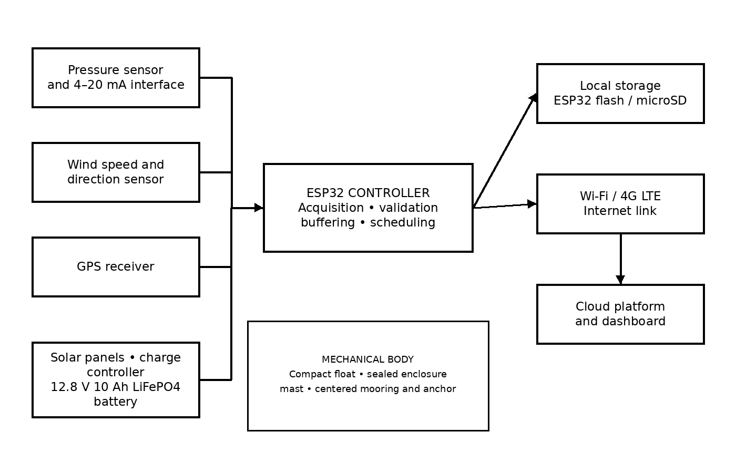
Figure 2.3. Proposed Hardware Block Diagram of Project FALCON
The software architecture separates the buoy firmware from the cloud service and from the dashboard. Buoy firmware is organized around deterministic acquisition, validation, event detection, telemetry framing, buffering, and upload scheduling. The cloud service is organized around authenticated ingestion, storage, pressure processing and wave estimation, alerting, the REST API, and the optional isolated prediction task. The dashboard consumes only the API and never reads a sensor directly, so a presentation defect cannot affect acquisition. Figure 2.4 presents this decomposition.
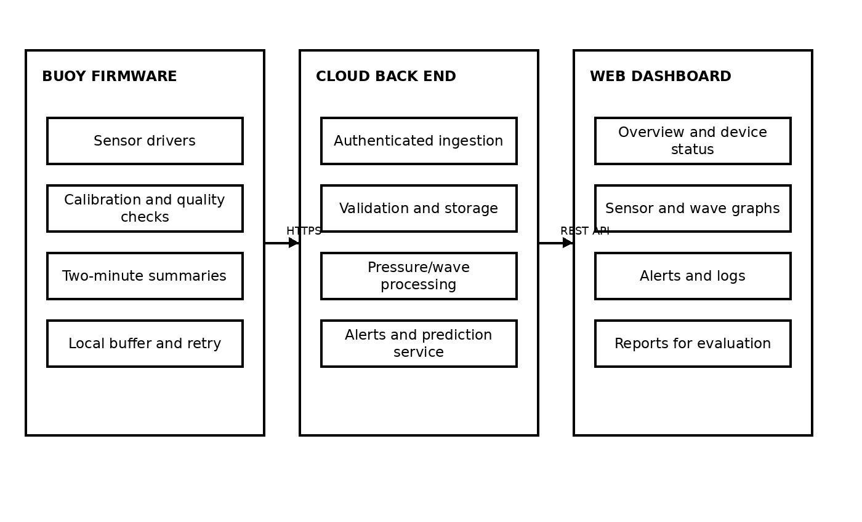
Figure 2.4. Proposed Software Architecture of Project FALCON
The hardware-software integration diagram in Figure 2.5 shows where each software task attaches to a physical interface. Pressure enters through the analog front end of the current-loop interface, wind speed and direction enter through their analog or pulse inputs, GPS arrives over a serial link, and battery and solar voltage arrive through the monitoring divider or monitor device. The ESP32 drives the charge-control and protection state indirectly through measurement rather than control, and it reaches the cloud through either the Wi-Fi radio or the LTE module. Every boundary shown is a selection or approval gate: the exact current-loop parts, the exact LTE board, and the cloud endpoint remain to be confirmed against datasheets and a real subscription before fabrication.
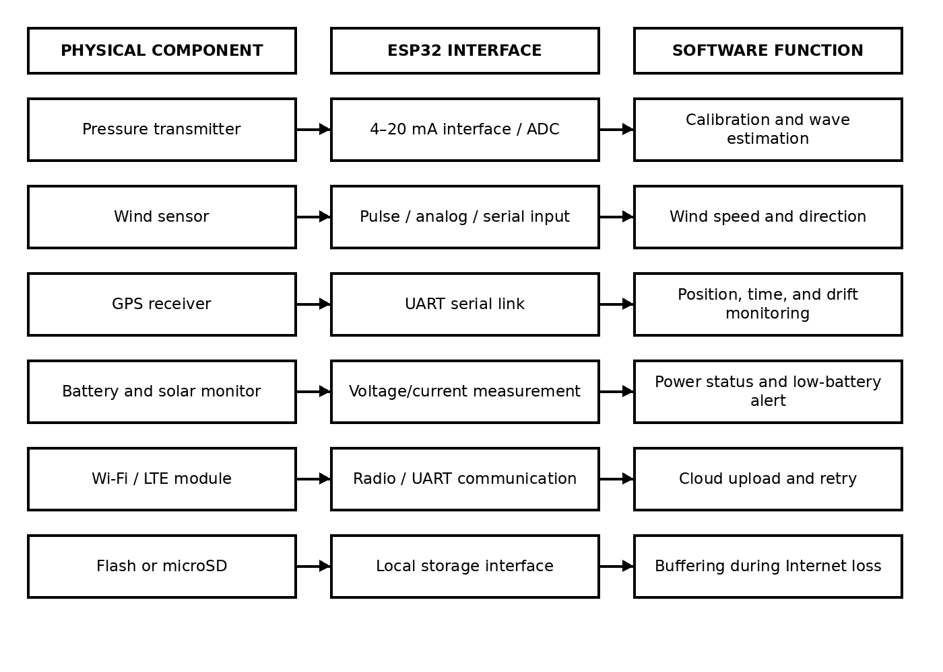
Figure 2.5. Proposed Hardware-Software Integration Diagram

2.2.5 System Flow Chart
Figure 2.6 shows the normal operating cycle of Project FALCON. The sensors collect pressure, wind, GPS, and power readings. The ESP32 validates each reading and stores valid data in the local buffer. When the two-minute window is complete, the controller creates a summary packet. If Internet service is available, the packet is uploaded to the cloud for storage, processing, and dashboard display. If Internet service is unavailable, the packet remains queued for a later upload.
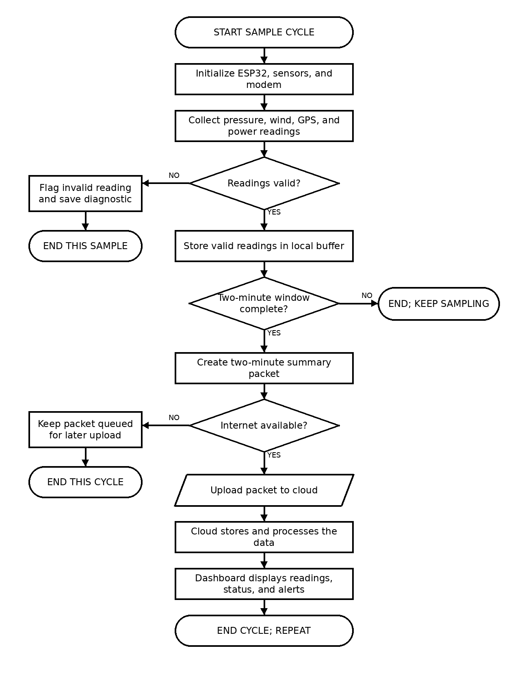
Figure 2.6. System Flow Chart of Project FALCON
Testing rubrics that apply to the whole design are stated once, in Section 2.6.3, rather than repeated here, so that each requirement, metric, and weight is defined in a single place.

2.3 Data Collection Methods
The following sections document the complete hardware, software, development, and validation elements requested in the revision notes. The diagrams are read together: the conceptual framework explains the research logic, the architecture diagrams explain the implementation, and the testing workflow explains how each claim will be checked.
This section defines what the buoy records, how often it records it, and under what conditions a record is transmitted. Five groups of data are collected. Table 1 states the source, the collection basis, and the intended use of each group.

Collection on the buoy is continuous, but transmission is conditional. The system does not upload one record per wave, because the ocean is never still and a normal wave must never be treated as a reportable event. Instead the ESP32 compares each new reading against a short-window baseline and transmits only in three situations. First, it sends a regular one-minute summary every one to five minutes during normal operation. Second, it sends an immediate packet when water pressure, wind speed or direction, GPS displacement, buoy tilt, battery or solar status, sensor health, or connection state crosses a validated threshold. Third, it sends queued records after the Internet path is restored. Each queued record keeps its original timestamp so that the stored series remains continuous.
While the Wi-Fi or LTE path is unavailable, records are written to the local buffer, which is a microSD card or the ESP32 flash ring buffer depending on the selected configuration. Losing the Internet path therefore delays a record rather than destroying it. Every value carries or inherits a timestamp, a source, a quality state, and a unit; a value that cannot be produced is stored as null rather than as a zero or a guess.
Raw pressure samples are retained locally in addition to the derived summary values. This is intentional: the raw series is what allows the wave-height estimation method to be recalculated and compared against an independent reference later, without having to repeat the field work. The collection rules described here are the design as proposed; the interval, the thresholds, and the buffer capacity are all calibration and approval items and remain to be validated on the bench before any field trial.
Data group | Source on the buoy | Collection basis | Intended use
Water pressure | Submersible pressure transmitter through the current-loop interface | Continuous local sampling at a fixed short interval; raw samples retained | Primary input for pressure-derived wave-height estimation
Wind speed and direction | Combined anemometer and wind vane, or the selected lower-cost alternative | Continuous local sampling at the same fixed interval | Environmental context and threshold-based alerting
Position and security | GPS receiver over serial link | Sampled at the same interval and compared against the last known position | Exact position, displacement monitoring, geofence and recovery support
Battery and solar state | Battery monitor or voltage divider on the power stage | Sampled at the same interval | Runtime validation, low-battery alerting, and power budget evidence
System and connection state | Firmware health flags, sensor health, and link status | Evaluated at each cycle | Diagnostics, data-quality labelling, and outage reporting

2.4 Software and Tools Used
This section lists the equipment, the mechanical body, and the software used to build and operate Project FALCON. Every item is recorded together with its role so that the selection can be reviewed against the low-cost requirement. The equipment list is a proposed configuration: exact part numbers, prices, and supplier quotations remain procurement-gate items, and no item is described here as purchased, assembled, or field-verified.

2.4.1 Hardware and Mechanical Body
The mechanical body carries every other component and is treated as part of the hardware specification rather than as a separate subject. Its elements are the float, the sealed electronics enclosure, the mast and solar bracket, the protected stilling tube for the pressure sensor, and the mooring chain and anchor. The enclosure volume is sized to hold the controller, the power stage, the battery, the antennas, and the buffer with room for cable routing and sealing.

2.4.2 Back-End Software
The back end performs everything that must happen between the arrival of a packet and the availability of a reading to a user. It accepts authenticated ingestion, detects stale data, filters pressure and derives wave height, logs events, stores records, exposes the REST API, and hosts the alert rules. Any prediction work is executed as an isolated task so that a slow or failed prediction can never block acquisition, storage, or the live reading.

2.4.3 Front-End Software
The front end is a responsive web dashboard with four primary pages in a fixed order: Overview, Buoy Motion, Sensors, and Logs and Alerts. Settings remains a compact header action rather than a fifth page. GPS position and security details are grouped under Sensors and summarised on Overview.

2.4.4 Development and Support Tools

Tool | Purpose
PlatformIO or the Arduino environment | Building, flashing, and debugging the ESP32 firmware
C / C++ for the firmware | Implementing acquisition, validation, event detection, buffering, and upload scheduling
Python with a web framework | Implementing the ingestion endpoint, validation, processing, and API
SQLite or an equivalent database | Storing readings, derived values, events, and configuration history
JavaScript with a component framework | Building the four-page dashboard
Chart rendering library | Rendering time-series and condition views in the dashboard
Git | Version control and change traceability
Documentation and diagram tools | Producing the figures, tables, and reports used in this study
Serial monitor and test runner | Bench observation of firmware behaviour and repeatable automated tests
Dashboard page | What it presents
Overview | Current conditions, estimated wave height, wind summary, power state, connectivity, and the short-term estimate with its state and input label
Buoy Motion | Visualisation of pressure-derived buoy movement as a presentation view; it does not require an inertial sensor
Sensors | Per-channel readings with units, source, quality state, and GPS position and security details
Logs and Alerts | Event history, alert history with triggering values, and connection or health records
Back-end component | Role
Ingestion endpoint | Accepts authenticated summary and event packets from the buoy and rejects malformed or unauthorised frames
Data validation | Checks range, timestamp ordering, source, and quality state before a record is accepted into storage
Storage | Keeps the received series, derived wave-height values, events, alerts, and configuration history
Pressure processing | Applies filtering and the wave-height estimation method to the pressure channel and labels the output as an estimate
REST API | Serves the dashboard and other clients with grouped, timestamped readings
Alert service | Evaluates threshold rules and raises, clears, and records alerts with their triggering value
Prediction service | Optional isolated short-term wave-height estimate; disabled or unavailable state must not affect monitoring
Hardware element | Proposed specification or class | Role in the system
Buoy body and float | Compact can or catamaran form with closed-cell flotation | Provides buoyancy, carries the mast and instruments, and holds the low centre of gravity required for stability
Electronics enclosure | Sealed low-profile housing with cable glands and a bolted hatch | Protects the controller, power stage, battery, antennas, and buffer from seawater and spray
Controller | ESP32 development board | Reads every sensor channel, validates data, detects events, buffers records, and schedules uploads
Water-pressure sensor | Holykell HPT604 Type A or an equivalent low-range submersible transmitter, vented gauge, 4-20 mA output | Primary input for pressure-derived wave-height estimation
Pressure interface | Precision shunt, RC filter, and clamp protection, or an equivalent analogue front end | Converts the 4-20 mA loop into a voltage the ESP32 can read
Wind sensor | Combined anemometer and wind vane, separate cup and vane, or the selected lower-cost alternative | Measures wind speed and wind direction for monitoring and alerting
GPS receiver | NEO-6M or a similar low-cost module | Provides exact position, displacement monitoring, and recovery support
Solar panel | Small panel sized from the measured load, mounted on a tilted bracket | Recharges the battery during daylight operation
Charge controller and regulation | PWM or MPPT charge controller with fuse and buck or boost regulation | Regulates charging and protects the battery and the loads
Battery | LiFePO4 or lithium-ion pack sized from measured modem duty | Supplies the system through darkness and through LTE transmission peaks
Battery monitoring | Battery monitor or a voltage-divider fallback | Reports state of charge and supports runtime validation and low-battery alerts
Internet module | ESP32 Wi-Fi for bench and near-shore work; A7670E, SIM7600, or equivalent 4G/LTE board with antenna and SIM for a remote trial | Carries summaries and event packets directly to the cloud endpoint
Local buffer | microSD module with an 8-32 GB card, or the ESP32 flash ring buffer | Preserves records and original timestamps during an Internet outage
Mast, bracket, and mooring | Support mast, solar bracket, chain, connector, and anchor | Presents the wind sensor and panel clear of the water and holds the buoy on station

2.5 Development Procedures
Development follows the staged sequence described in Section 2.1: requirements analysis, system design, system development and integration, testing and evaluation, and revision. This section states the concrete procedures carried out inside those stages for the two data paths that require the most explanation: the processing of pressure data into an estimated wave height, and the short-term prediction workflow that consumes those estimates.
Before any procedure is executed, the team records the configuration under test, the firmware and software version, and the instruments used. Bench procedures are carried out indoors on a stable supply; controlled-water procedures are carried out in a container or tank with a measured water column; and any near-shore activity is planned and supervised, with no deployment during severe weather, in a navigation channel, or without an approved mooring plan. Results are recorded whether they are favourable or not, and no procedure is reported as passed without a stored record.

2.5.1 Pressure Data Processing Flowchart
Figure 2.7 explains the water-pressure sensor. Water pushes on the submerged sensor. The sensor sends an electrical signal to the ESP32. The ESP32 converts that signal into a pressure value using the sensor calibration. It checks the value and marks it if it is impossible or noisy. The system then removes the slow change caused by the buoy being deeper or shallower. What remains is the pressure change caused by the passing wave. The system reports this as an estimated wave change and compares it with a reference measurement before calling it a validated wave height.
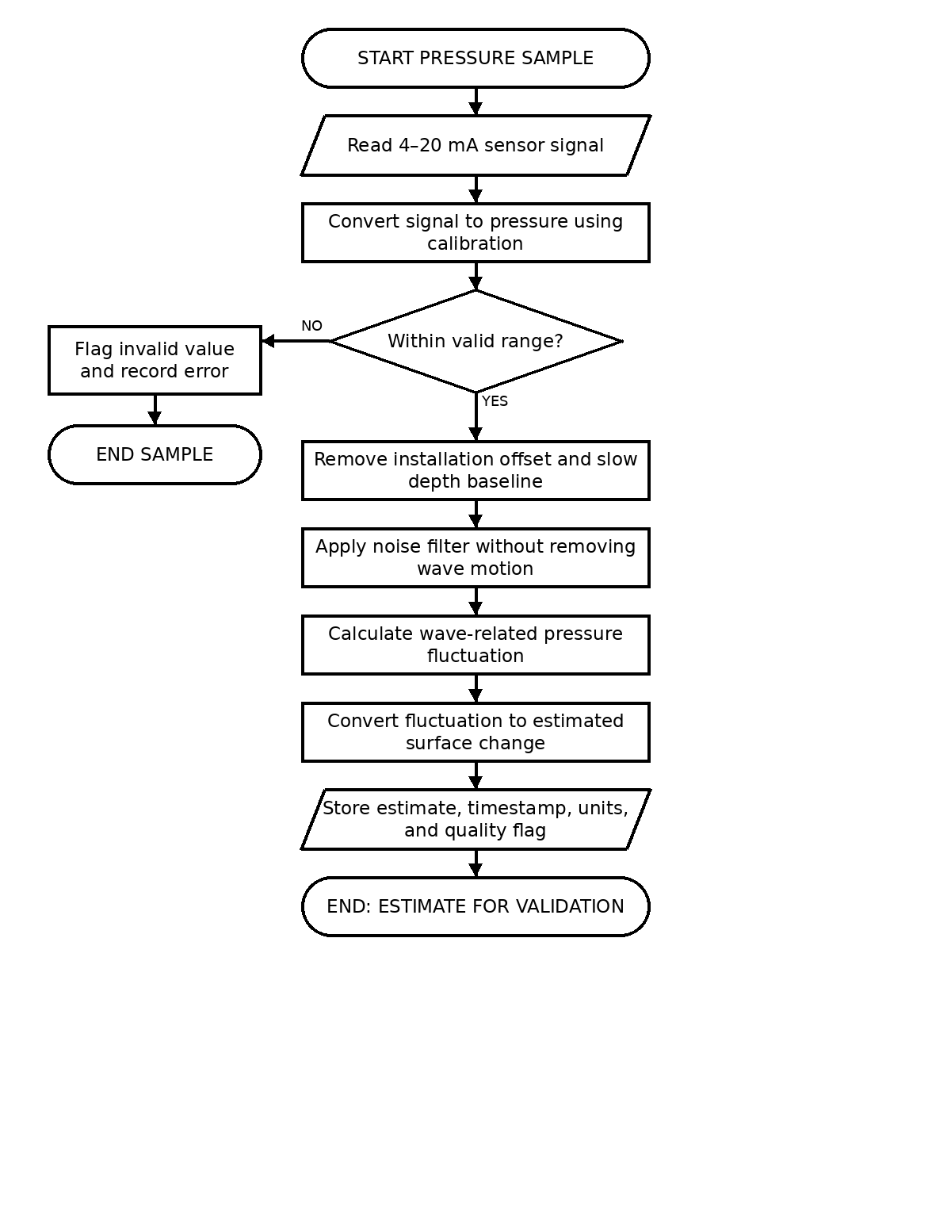
Figure 2.7. Pressure Data Processing Flowchart

2.5.2 AI Prediction Model Workflow
The prediction workflow is shown in Figure 2.8. It begins with the stored series of estimated wave heights, applies a preparation step that removes non-good records and enforces a minimum history before any estimate is produced, and then produces a five-, ten-, or fifteen-minute short-term estimate together with an expected condition label and a confidence indicator. When fewer than eight valid records are available the workflow returns a collecting state instead of an estimate, so that the dashboard never presents an invented value.
The present implementation is a transparent damped-trend research baseline. It is implemented software, but it is not yet a trained or field-validated model and it is not an official marine forecast. Reaching a state where prediction accuracy may be reported requires calibrated live data, an explicit separation of training, validation, and test sets, comparison against the current baseline, and recorded mean absolute error, root mean squared error, and bias. Until those steps are complete, the workflow is documented as proposed and its output is presented as a research estimate with its state and input label visible.
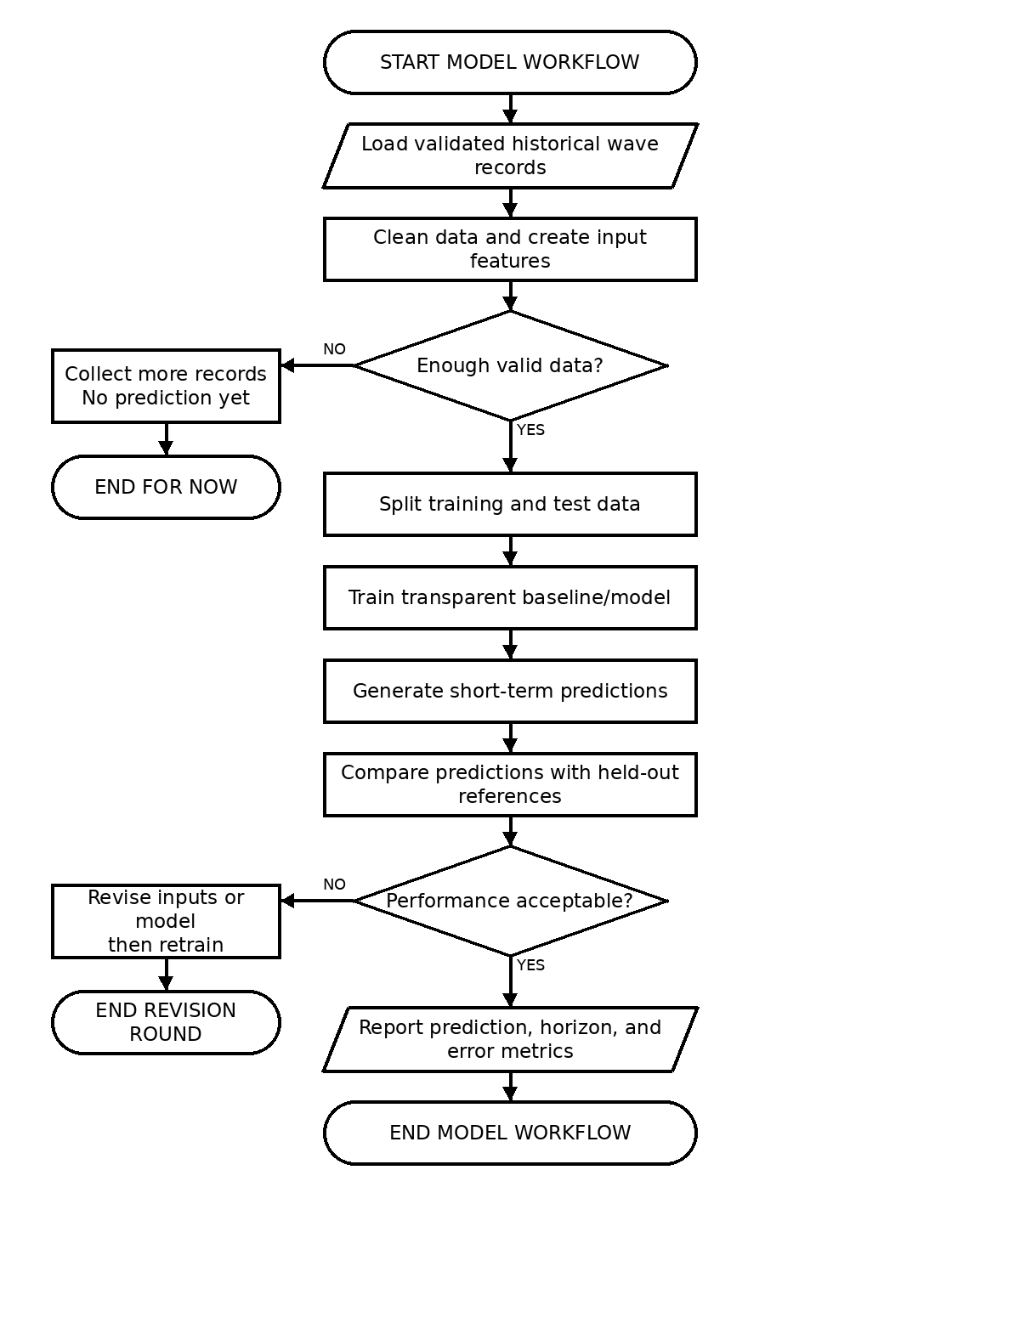
Figure 2.8. AI Prediction Model Workflow

2.6 Testing and Evaluation
Testing establishes whether the proposed system behaves as specified; evaluation converts those observations into a comparable judgement. The two are kept separate on purpose so that a passing observation and a satisfactory score are not confused with one another. All methods below are proposed methods and all acceptance values are proposed targets; none of them has been executed as a completed validation at the time of writing.

2.6.1 Testing and Validation Workflow
Figure 2.9 shows the ordered workflow. The configuration under test is recorded, the equipment is inspected and the enclosure is leak-checked, the sensors are calibrated or compared against a reference, the system is exercised on a bench supply, a controlled-water test is carried out with a measured water column, the communication and power paths are exercised under their own conditions, and the results are scored against the criteria in Section 2.6.3. Any failure returns the work to the design, calibration, or firmware stage and the workflow is repeated. Calibration data and verification data are kept separate so that a method is not evaluated against the same records used to tune it.
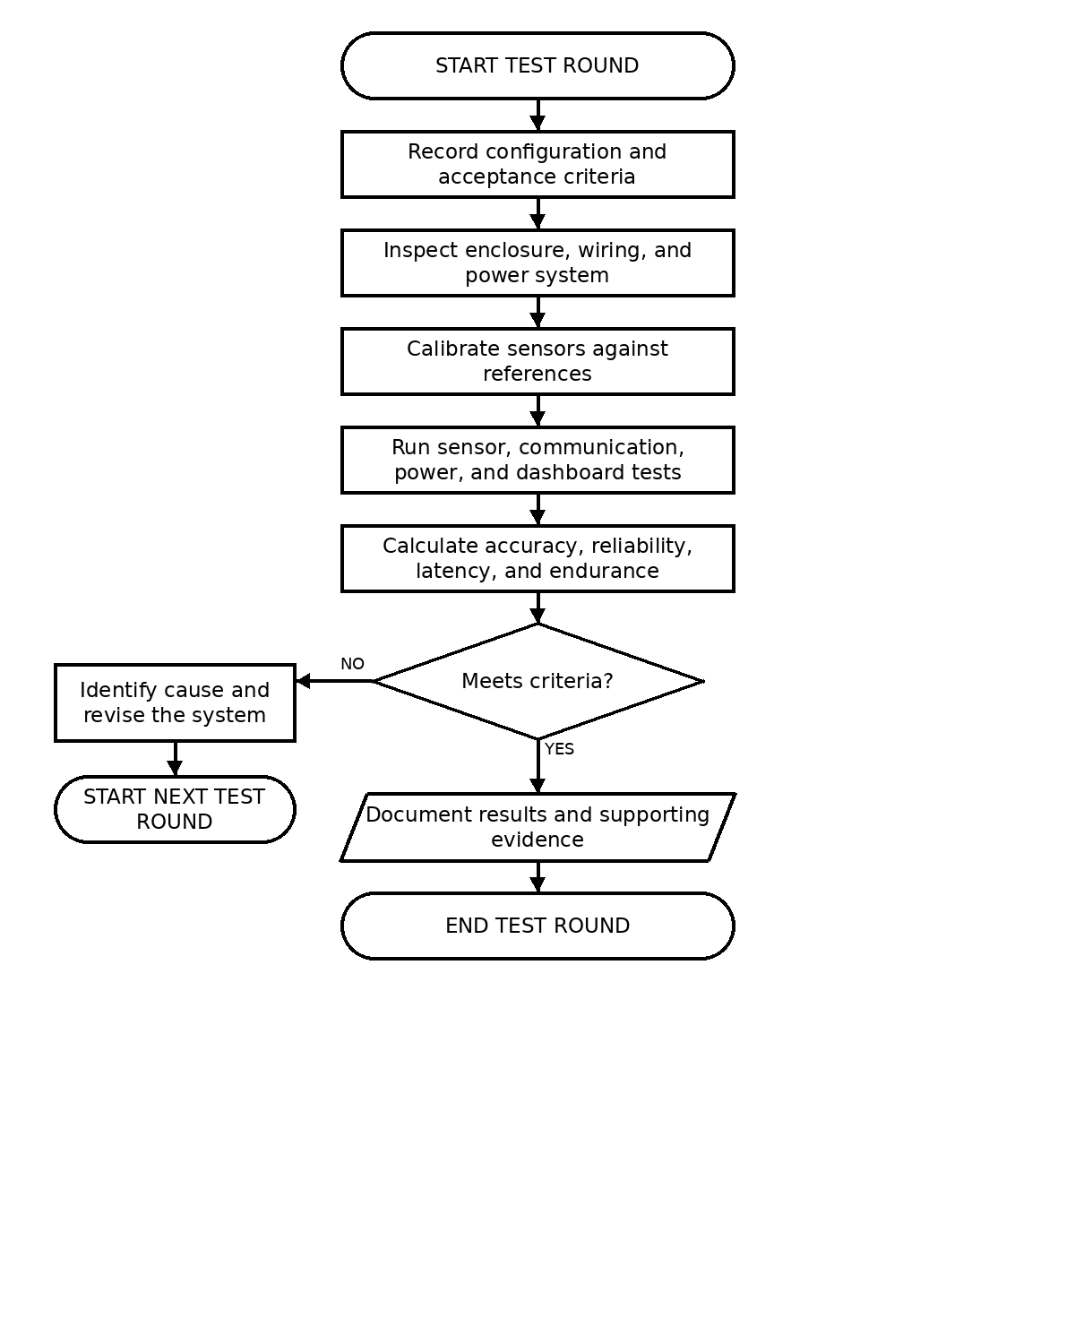
Figure 2.9. Testing and Validation Workflow

2.6.2 Testing Methods

2.6.3 Evaluation Criteria and Testing Rubrics
Wave-height accuracy is evaluated against an independent reference instrument. For a reference series y and an estimated series y-hat over n paired records, the metrics are:
Mean Absolute Error: MAE = (1 / n) * SUM | y(i) - y_hat(i) |
Root Mean Squared Error: RMSE = SQRT( (1 / n) * SUM ( y(i) - y_hat(i) )^2 )
Mean Bias: MB = (1 / n) * SUM ( y(i) - y_hat(i) )
Mean Absolute Percentage Error: MAPE = (100 / n) * SUM | y(i) - y_hat(i) | / | y(i) |
Communication and data handling are evaluated with simple ratios. Data completeness is the number of expected records received divided by the number of records expected, multiplied by one hundred. Packet delivery ratio is the number of packets received divided by the number of packets sent, multiplied by one hundred. Power endurance is reported as the achieved runtime in hours against the designed runtime, together with the average system current that produced it.
Packet delivery ratio (PDR) = (received packets / transmitted packets) × 100. Data completeness = (valid records received / expected records) × 100. Upload latency is measured as the cloud-receipt timestamp minus the end of the corresponding sampling window.
For event detection, precision = TP/(TP + FP) and recall = TP/(TP + FN), where TP, FP, and FN are true positives, false positives, and false negatives. These measures will be reported only when the test produces enough labelled event and non-event cases.
For power, measured autonomy is reported in hours until the battery reaches the approved low-voltage cutoff under the defined load. The solar subsystem is evaluated by comparing daily harvested energy with daily consumption; the result is reported as a test observation, not as a guaranteed field endurance claim.
Mean Absolute Percentage Error is not used when the reference wave height is zero or near zero because it becomes unstable. MAE, RMSE, mean bias, normalized RMSE, PDR, completeness, latency, event precision/recall, and measured autonomy are the primary evaluation measures.
Table 2 states the proposed evaluation metrics and the targets against which each will be judged. These targets are planning values used to organise the work; they are not measured results.

Table 3 converts these criteria into a weighted scoring rubric so that a single overall judgement can be recorded for each test round. The weights are proposed and may be revised by the adviser; the score is reported alongside its underlying metric so that a total never hides a failing measurement.

Each test round is recorded as a dated entry containing the configuration, the software version, the metrics obtained, the target applied, and the resulting pass, conditional, or fail status. A conditional or fail status returns the work to the relevant development stage. No test round may be reported as a field result until the enclosure, power, calibration, and communication gates have been closed on the bench and the trial plan has been approved.
Rubric criterion | Weight | Scoring basis
Measurement accuracy | 30% | Reported from the wave-height error metrics in Table 2
Communication reliability | 20% | Reported from packet delivery and queued-record delivery
Power performance | 20% | Reported from achieved runtime against designed runtime
Data integrity and event correctness | 15% | Reported from completeness, timestamp retention, and false-trigger count
Usability and documentation | 15% | Reported from the structured task-completion rubric
Evaluation criterion | Metric | Proposed target | Evidence required
Wave-height estimation accuracy | MAE and RMSE against the reference instrument | To be set with the adviser after the reference method is confirmed | Paired reference and estimated series with both calibration and verification records
Estimation bias | Mean bias | Near zero, with the sign and magnitude reported | Signed residual series over the verification set
Data completeness | Received records / expected records * 100 | Not to be claimed until the collection interval is fixed | Storage extracts compared against the expected schedule
Communication reliability | Packet delivery ratio and queued-record delivery after recovery | Full delivery of queued records after every simulated outage | Sent and received packet logs with original timestamps
Event detection correctness | True triggers versus false triggers | No upload caused by ordinary wave movement alone | Event log with triggering values and suppression records
Power endurance | Achieved runtime against designed runtime | Designed runtime met through a simulated dark period | Voltage and current traces with the transmission schedule
Prediction usefulness | MAE, RMSE, and bias against the held-out set | Must outperform the damped-trend baseline before any accuracy claim | Versioned evaluation record with training, validation, and test separation
Usability | Structured task-completion feedback | Reviewer completes each task without assistance | Completed rubric forms and observed task outcomes
Testing method | What is exercised | Record produced
Enclosure and leak inspection | Sealing of the enclosure, cable glands, and hatch before and after immersion | Inspection record and any observed water ingress
Static depth calibration | Pressure sensor against a measured water column at known depths | Calibration curve, offset, and residual error
Controlled stilling-tube response | Response of the protected sensor mount to a known water-level change | Response trace used to label the wave-height estimate
Wind sensor comparison | Wind speed and direction against a reference anemometer and vane | Comparison readings and observed deviation
Power endurance test | Operation from the battery through a simulated dark period while transmitting | Current draw, voltage trace, and achieved runtime
Communication test | Summary and event delivery over Wi-Fi and over the LTE path, including outage and recovery | Packets sent, packets received, latency, and queued-record delivery
Event detection test | Threshold crossing, debounce, and suppression of ordinary wave movement | Triggered events with triggering values and false-trigger count
Buffer and recovery test | Local recording during an Internet outage and replay after reconnection | Records preserved, original timestamps retained, and duplicates
Dashboard usability review | Whether a reviewer can find current conditions, an alert, and a history entry | Task completion observations and structured feedback

2.7 Ethical Considerations
Participation will be voluntary and based on an informed-consent form written in understandable language. The form will explain the purpose, activities, expected duration, possible inconvenience, absence of guaranteed direct benefit, confidentiality measures, and contact person. Participants may refuse any question or stop before submission without penalty. Recruitment will avoid coercion, and supervisors or researchers will not pressure students, employees, or community members to join.
The study will collect only the participant information needed for eligibility and analysis. Names and contact details will be separated from response data and replaced with codes. Access will be limited to the research team and adviser. Electronic files will use controlled access and encrypted storage where available; printed consent forms will be kept separately in a secured location. Public datasets and screenshots will exclude personal identifiers, account details, exact sensitive coordinates, credentials, and SIM information. Records will be retained through the final defense and for one year afterward, unless the institution requires a different period, and will then be securely deleted or destroyed in accordance with the Data Privacy Act of 2012 (Republic Act No. 10173, 2012).
Field activities will follow a written safety and retrieval plan. The prototype will not be deployed during severe weather, in a navigation channel, or without an approved mooring and responsible on-site supervision. The dashboard will display experimental, stale, simulated, calibration-required, and unavailable labels as applicable. Participants will be told that FALCON is not an official warning or navigation instrument and that safety decisions must use authorized government information.
Results will be disseminated through the thesis manuscript and defense, an adviser-approved technical report, and a concise findings letter or presentation for DOST, Fullbright College, the participating barangay or local office, and other approved partners. Publication or conference presentation may follow institutional approval. Reports will include unsuccessful tests and limitations, will avoid identifying participants, and will not reveal sensitive deployment information that could increase theft or interference risk.

References
Cabrera, O., Villanoy, C., & Siringan, F. P. (2016). Wave climate of the Philippines from Wavewatch III global model. 2016 Ocean Sciences Meeting. https://studio.m-anage.com/agu/os16/preliminaryview.cgi/Paper89449.html
Pacaldo, J. C., Bilgera, P. H. T., & Abundo, M. L. S. (2022). Nearshore wave energy resource assessment for off-grid islands: A case study in Cuyo Island, Palawan, Philippines. Energies, 15(22), 8637. https://doi.org/10.3390/en15228637
Department of Science and Technology–Advanced Science and Technology Institute. (2024, October 22). Fish kill forecasting a priority for DOST-ASTI’s continuous metbuoy development. https://asti.dost.gov.ph/news-articles/fish-kill-forecasting-a-priority-for-dost-astis-continuous-metbuoy-development/

Lyman, T. P., Elsmore, K., Gaylord, B., Byrnes, J. E. K., & Miller, L. P. (2020). Open wave height logger: An open-source pressure sensor data logger for wave measurement. Limnology and Oceanography: Methods, 18(7), 335–345. https://doi.org/10.1002/lom3.10370
Trevathan, J., & Schmidtke, S. (2022). Open-source Internet of Things remote aquatic environmental sensing. HardwareX, 12, e00336. https://doi.org/10.1016/j.ohx.2022.e00336
Yevnin, Y., Chorev, S., Dukan, I., & Toledo, Y. (2023). Short-term wave forecasts using gated recurrent unit model. Ocean Engineering, 268, Article 113389. https://doi.org/10.1016/j.oceaneng.2022.113389
Republic Act No. 9729. (2009). Climate Change Act of 2009. Supreme Court E-Library. https://elibrary.judiciary.gov.ph/thebookshelf/showdocs/2/18615
Republic Act No. 10121. (2010). Philippine Disaster Risk Reduction and Management Act of 2010. Supreme Court E-Library. https://elibrary.judiciary.gov.ph/thebookshelf/showdocs/2/21121
Republic Act No. 10173. (2012). Data Privacy Act of 2012. Official Gazette of the Republic of the Philippines. https://officialgazette.gov.ph/2012/08/15/republic-act-no-10173/
Republic Act No. 10692. (2015). PAGASA Modernization Act of 2015. Supreme Court E-Library. https://elibrary.judiciary.gov.ph/thebookshelf/showdocs/2/65229

Escudero-Mancebo, D., Fernández-Villalobos, N., Martín-Llorente, Ó., et al. (2023). Research methods in engineering design: A synthesis of recent studies using a systematic literature review. Research in Engineering Design, 34, 221–256. https://doi.org/10.1007/s00163-022-00406-y
Benfell, A. (2021). Modeling functional requirements using tacit knowledge: A design science research methodology informed approach. Requirements Engineering, 26, 25–42. https://doi.org/10.1007/s00766-020-00330-4
Hertzum, M. (2026). System Usability Scale: A meta-analysis of how SUS relates to workload, task time, and error rate. International Journal of Human–Computer Interaction. https://doi.org/10.1080/10447318.2026.2625260
Skålvik, A. M., Sætre, C., Frøysa, K.-E., Bjørk, R. N., & Tengberg, A. (2023). Challenges, limitations, and measurement strategies to ensure data quality in deep-sea sensors. Frontiers in Marine Science, 10, Article 1152236. https://doi.org/10.3389/fmars.2023.1152236
Varela, D. A. B., Ongsakul, W., & Benitez, I. B. (2024). Machine learning applications in wave energy forecasting. In 2024 International Conference on Sustainable Energy Energy Transition and Net-Zero Climate Future (pp. 1-8). IEEE. https://doi.org/10.1109/ICUE63019.2024.10795514
von Bertalanffy, L. (1968). General system theory: Foundations, development, applications. George Braziller.
Williams, Z., Soto Calvo, M. A., Lee, H. S., Aljber, M., & Jeong, J.-S. (2025). A low-cost autonomous multi-functional buoy for ocean currents and seawater parameter monitoring, and particle tracking. Journal of Marine Science and Engineering, 13(9), Article 1629. https://doi.org/10.3390/jmse13091629
Zhang, H., Zhang, D., & Zhang, A. (2020). An innovative multifunctional buoy design for monitoring continuous environmental dynamics at Tianjin Port. IEEE Access, 8, 171820-171833. https://doi.org/10.1109/ACCESS.2020.3024020
Zhao, Q., Peng, S., Wang, J., Li, S., Hou, Z., & Zhong, G. (2024). Applications of deep learning in physical oceanography: A comprehensive review. Frontiers in Marine Science, 11, Article 1396322. https://doi.org/10.3389/fmars.2024.1396322

APPENDIX A
LETTER TO THE DEAN (SAMPLE)
< d a t e >
Jezree B. Vicente, PhD
Dean, College of Criminal Justice Education
Fullbright College
San Jose, Puerto Princesa City
Dear Dean Vicente:
A pleasant day.
The undersigned are students of <state your course in full> and are currently writing a thesis entitled <state the title of your thesis in full text>.
In this regard, may we ask permission from your office to commence the data gathering. Upon the approval of your office of this letter, the undersigned researchers will make a letter to the concerned key persons to coordinate the data gathering.
Thank you.
Respectfully yours.
<leave 4 spaces>
Firstname M.I. Surnames (same with the arrangement in the title page) Researchers
Recommended by:
Firstname M.I. Surname Firstname M.I. Surname Subject Instructor Adviser
Approved:
Jezreel B. Vicente, PhD
Dean

APPENDIX B
LETTER TO THE CITY DIRECTOR, PPCPO
<date>
PCOL CRISTINE M TABDI
City Director
Puerto Princesa City Police Office
Puerto Princesa City
Dear Sir:
The undersigned are students of <state your course in full> and are currently writing a thesis entitled <state the title of your dissertation in full text> as the terminal requirement to finish the degree. The purpose of this research is to <state the main purpose only.>
Relative to this research, may we ask permission from your good office for us to administer the questionnaires, conduct interviews with selected personnel. Rest assured that we will abide by the rules of ethics of research and bound by the rules of confidentiality as we gather the data. We will only use the data for research purposes. Thank you.
Respectfully yours.
<leave 4 spaces>
Firstname M.I. Surnames (alphabetical based on surnames)
Researchers
Noted by:
Firstname M.I. Surname
Adviser
Noted by:
Jezreel B. Vicente, PhD Dr. Edgardo Castillo
Dean, CCJE Dean, Research and Extension Approved:
Eleuterius L. Edualino
President, Fullbright College

APPENDIX C
LETTER TO THE RESEARCH PARTICIPANTS
<date>
Dear <Respondent/Informant>,
The undersigned are students of <state your course in full> and are currently writing a thesis entitled <state the title of your thesis in full text> as the terminal requirement to finish the degree. The purpose of this research is to <state the main purpose only.>
In this regard, may we request you to answer the attached <questionnaire / interview questions> about our study. Rest assured that the data collected will be used solely for this research without compromising the confidentiality and integrity of the agency you represent.
You have the right to refuse to participate in this research study. Also, you have the right to withdraw the information you provided to the researchers.
Thank you.
Respectfully yours.
<leave 4 spaces>
Firstname M.I. Surname (same arrangement in the title page) Researchers
Recommended by:
Firstname M.I. Surname Firstname M.I. Surname Research Instructor Adviser
Approved:
Jezreel B. Vicente, PhD
Dean

APPENDIX D
RESEARCH TOOL
If you used a questionnaire and/or an interview guide, attach them in this section. Do not create a separate appendix for each instrument. If you used two instruments, include both in this appendix and clearly label each one.

APPENDIX E
CERTIFICATION OF RESEARCH TOOL VALIDATION
CERTIFICATION OF RESEARCH TOOL VALIDATION
This is to certify that the research instrument titled: __________________ ________________________________________________________________ has been thoroughly reviewed and validated by the undersigned, serving as the Subject Instructor and the Research Adviser, respectively, to ensure its content validity, relevance, clarity, and appropriateness to the research objectives and questions of the study.
After careful examination, the tool was found to be appropriate and acceptable for data gathering purposes in partial fulfillment of the requirements for the degree of <Bachelor of Science in Criminology>
Validated this ___ day of _________, 2025, at Fullbright College, Puerto Princesa City, Palawan.
VALIDATORS:
Firstname M.I. Surname
Research Instructor
(Signature over Printed Name)
Firstname M.I. Surname
Research Adviser
(Signature over Printed Name)

APPENDIX F
PHOTO DOCUMENTATION

INSTRUCTIONS:
In this appendix, attached 3 photos during the:
a. Consultative Meeting of researchers (with caption)
b. Consultative Meeting with the adviser (with caption)
c. Consultative meeting with the research teacher (with caption)

